Supplementary Figure S3. Comparisons of genic features between *Hypsibius dujardini* and *Ramazzottius varieornatus*

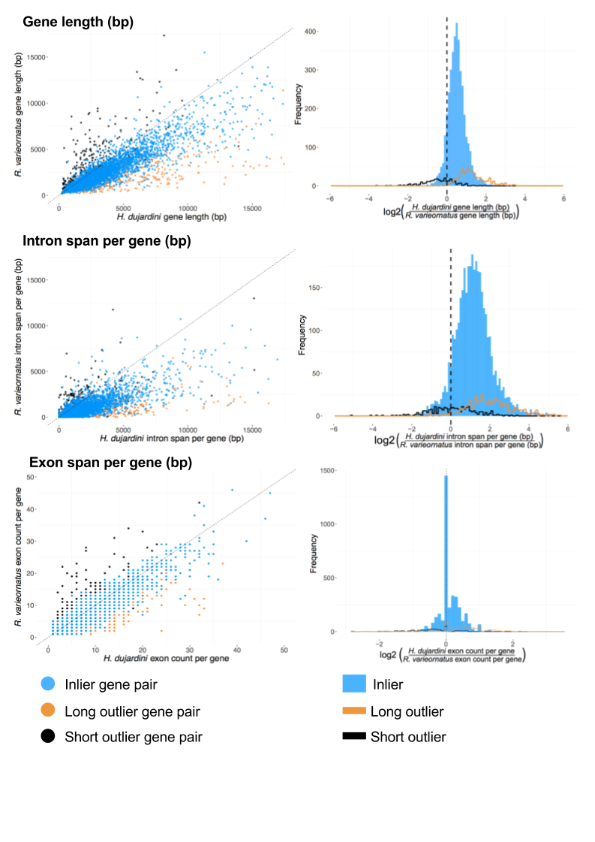

Comparisons of genes structures in 4728 single-copy orthologues between *H. dujardini* and *R. varieornatus.* Outliers are defined as genes in *H. dujardini* which have CDS lengths 20% longer (long outliers; orange; 576 genes) or 20% shorter (short outliers; black; 294 genes) than their orthologues in *R. varieornatus.* Left panels show ascatter plots, with *H. dujardini* on the X and *R. varieornatus* on the Y axes.Right panels show frequency histograms of the ratios of genic feature lengths per gene. A positive log2 ratio indicates a trend towards a larger count or span in *H. dujardini*.